

IV

# 3. MOVEMENTS OF THE EARTH

1. **Choose the correct answer**
   1. The Earth takes to complete a rotation with respect to the Sun.

a. 30 days b.24 days c.365 days d.6 months

* 1. Which of the following causes day and night?

a. Rotation b. Revolution c. Equinox d. Constellation

* 1. Daylight is less in which season?

a. Summer b. Winter c. Autumn d. Spring

* 1. Revolution is the movement of the Earth around the .

a. Moon b. Sun c. Venus d. Pluto

* 1. The imaginary line drawing the Earth into two halves is tailed .

a. orbit b. half-line c. equator d. path

* 1. The only planet with life in the solar system is .

a. Moon b. Sun c. Earth d. Mars

* 1. The Sun rises in the east and sets in the west. In what direction is the Earth rotating?
     1. East to West b West to East c. North to South d. South to North
  2. Arrange the following in the increasing order of the size. The Earth, the Moon and the Sun .
     1. the Sun- the Moon -the Earth b. the Moon- the Sun – the Earth

c. the Earth-the Moon –The Sun d. the Moon-the Earth-the Sun

# Observe the diagram given below and answer the questions

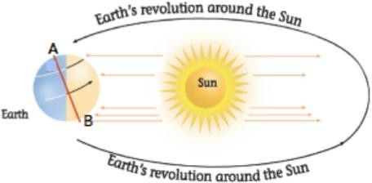

1. .What does it show?
2. According to this diagram, which point on the Earth is experiencing a warmer weather?

c .Point A or B? Explain why this is happening?

1. Do you think both A and B will experience the same season for a few months?

Why do you think so?

1. Which seasons are point A and B experiencing?